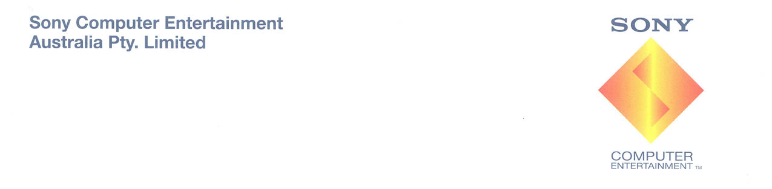

Sony Computer Entertainment Australia Confirms PLAYSTATION®3 80GB Model Launch Date
Double the storage capacity, plus a DUALSHOCK®3 controller, for $699

Sydney, 15 August 2008 – Sony Computer Entertainment Australia (SCE Aust.) today confirmed the 28th August 2008 as the Australian release date for its new PLAYSTATION®3 (PS3™) 80GB model, replacing the current 40GB version. The new model, announced at E3 in July, offers all of the features and functionality of the 40GB model, but with double the storage to accommodate more games, movies, graphics, music, photos and other entertainment content – all at the same recommended retail price of $699.

Not only does the new PS3 model offer increased storage, but it also ships with a DUALSHOCK®3 Wireless Controller. Utilising Bluetooth technology for wireless game play, the DUALSHOCK 3 provides the most intuitive and involved game play experience thanks to the inclusion of SIXAXIS™ motion sensing technology and in-built rumble, ensuring each hit, crash and explosion is more realistic than ever.

“Having achieved an install base of over 350,000 consoles to date, the PS3 has already found its place in many Australian homes,” said Michael Ephraim, Managing Director SCE Aust. and New Zealand. “With more compelling content being made available to PS3 owners every week through the PLAYSTATION®Network, the extra storage offered in this new model will prove invaluable.”

“In addition, the 80GB memory allows you consolidate all of your digital music, photos and movies in one central place within the home and experience them on a high definition TV. Add to this the ability to enjoy Blu-ray movies and games and it’s clear why the PS3 has earned its place as the leading entertainment hub in today’s home.”

Thanks to a constantly expanding and diverse software line-up, the PS3 continues to grow in its appeal to a broad range of consumers; from hard-core gamers through to general entertainment enthusiasts. While upcoming exclusive blockbuster PS3 titles, such as Resistance 2™ and SOCOM: U.S. Navy SEALs Confrontation™, appeal to gaming enthusiasts, other titles like MotorStorm™ Pacific Rift and LittleBIGPlanet™ can be enjoyed by anyone who’s looking for pure entertainment. Add to this the arrival of PlayStation’s leading social gaming titles like SingStar® and Buzz!™ to the PS3 platform and there is something on offer for every type of entertainment seeker.
- ENDS -

Notes to Editors:

For more information and images of the new 80GB PS3 or other PlayStation products, please visit www.scee.presscentre.com/au or contact:

Andrés López-Varela Povel Torudd
Hausmann Communications Hausmann Communications
Ph: 02 8353 5773 Ph: 02 8353 5747
Email: andres@hausmann.com.au Email: povel.torudd@hausmann.com.au

About Sony Computer Entertainment Europe Ltd

Sony Computer Entertainment Europe (SCEE), based in London, is responsible for the distribution, marketing and sales of PLAYSTATION®3, PlayStation®2, PSP™ (PlayStation®Portable) and PLAYSTATION®Network software and hardware in 99 territories across Europe, the Middle East, Africa and Oceania. SCEE also develops, publishes, markets and distributes entertainment software for these formats, and manages the third party licensing programs for the formats in these territories. Since the launch of PLAYSTATION 3 in November 2006, over 12.5 million units have been sold globally and continue to be sold at a record level. Maintaining its position as one of the most successful consumer electronic products in history, PlayStation 2 has sold over 129 million systems worldwide. Since its launch at the end of 2004, over 37.5 million PSPs have been sold globally, highlighting the importance of the portable entertainment market. With the huge increase in interest and accessibility of network applications and network gaming, over 9 million people have registered to the PLAYSTATION Network, the free-to-access interactive environment, and 160 million items have been downloaded.

About Sony Computer Entertainment Australia

Sony Computer Entertainment Australia (SCE Aust.) is responsible for the distribution, marketing, sales and network support of PLAYSTATION®3, PlayStation®2 and PSP® (PlayStation®Portable) and PLAYSTATION®Network software and hardware in Australia and New Zealand. SCE Aust. commenced trading in 1995.

More information about PlayStation products can be found at www.playstation.com.au or visit the Virtual Press Office at www.scee.presscentre.com/au

PlayStation, PSP and the PlayStation logo are registered trademarks of Sony Computer Entertainment Inc. UMD (Universal Media Disc) is a trademark of Sony Computer Entertainment Inc. All other trademarks are property of their respective owners.

